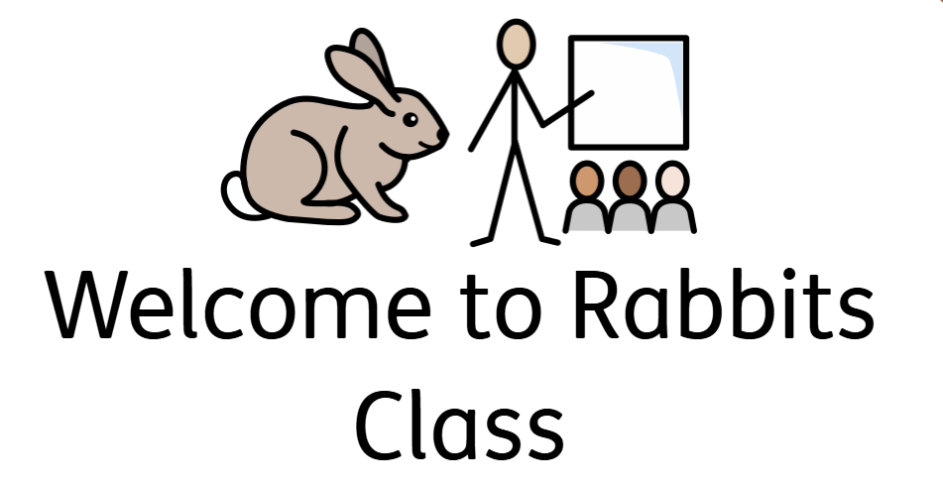
Hello everyone, welcome to Rabbits Class!

In our Rabbits class our teacher is Mrs Atkinson, and we will be supported by Mrs White. On a Monday afternoon, we will be supported by Mrs Shuttleworth while Mrs Atkinson has her teacher planning time.
Curriculum
We are delighted to welcome you and your child to Rabbits Class as we begin this exciting school journey together.
Our primary focus will be on developing essential life skills, including independence, social interaction, emotional wellbeing, mental health, and physical development. These areas form the foundation of our approach and are central to supporting each child’s holistic growth.
To ensure that every child receives a tailored and meaningful learning experience, we will be using their individual targets to guide our planning. This will be delivered through the EQUALS curriculum, thoughtfully integrated with the Early Years Foundation Stage (EYFS) framework. We look forward to working in partnership with you to support your child’s progress and celebrate their achievements throughout the year.
Rules and Rewards
This year we are continuing to follow our 3 school rules:
 Be Safe
Be Ready
Be Respectful
As well as our school motto:
‘Believe and Achieve’

In Rabbits Class, we use ClassDojo to celebrate positive behaviour and personal progress. Children earn points throughout the week, and the top scorer becomes our Dojo Winner, receiving a certificate in assembly and a non-uniform day the following week.
While our focus is on encouragement, points may be removed for incomplete homework or behaviour that needs reflection, always with sensitivity to each child’s needs.
We’ll also continue awarding Golden Moment Certificates each week to recognise achievements across the whole class—at least two children will be celebrated every Friday.

Resources
To help your child feel comfortable and ready for each day, please ensure they bring a water bottle to stay hydrated, and have their reading book and reading record in their bag daily.
For outdoor and Forest School activities, children will need:
- A waterproof coat
- Wellies
- Spare clothes, including socks and underwear
- Clothes suitable for outdoor learning, such as scruffy over-clothes, which can be left on their peg

Medical needs
If your child has any medical needs please inform me as soon as possible, if they require an inhaler in school, please provide one that can be kept in the classroom.

Reading and Homework
In Rabbits Class, we encourage all children to engage with books in a way that suits their individual needs and interests. This might include exploring books at home, looking at pictures, listening to stories read aloud, or beginning to blend sounds and words. As the children settle into school, we will gradually introduce book exploration as part of their daily routine. Our aim is to nurture a love of reading—whatever form that may take. We would be delighted to see photos of you sharing books together at home, which can be uploaded to ClassDojo. We encourage families to enjoy reading activities at least three times per week.
Children who have explored a story three times during the week will receive a homework Dojo point to celebrate their engagement.

A homework menu will be sent home at the start of each half term and shared on our ClassDojo story. Children can choose activities that suit their interests and strengths, and each completed task earns 10 Dojo points.

P.E.
P.E. sessions for Rabbits Class will take place on Tuesday and Friday mornings. Children should bring a full P.E. kit on these days, or it can be kept on their peg at school for convenience.
To help develop independence and self-care skills, we will support children in practising how to change into their P.E. kit and back into their uniform. This is a valuable part of their learning and daily routine.
For safety during physical activities:
- Long hair must be tied back
- Earrings must not be worn during P.E. lessons
– Please note: Tape over earrings is not accepted.
– Children must be able to remove earrings independently before the lesson. If they are unable to do so, earrings should be removed before coming to school, as staff are not permitted to assist with this.

If you would like to speak with me about anything, please feel free to contact me via ClassDojo, or come and see me at the end of the day once all children have been safely dismissed.

I’m truly excited to be teaching your child this year and look forward to a wonderful journey together. Thank you for your continued support!

Mrs Georgia Atkinson

